## Coastal A Zone – FPM ordinance text changes and local technical code amendments (FBC, R)

## Alternative A: apply Zone V standards in Coastal A Zones if FEMA has delineated a Limit of Moderate Wave Action

**NOTE!** The 2015 I-Codes, on which the 6th Edition FBC will be based, require Coastal A Zones to be regulated like Zone V if FEMA has delineated the LiMWA or the community has otherwise designated the CAZ. Also, in all flood zones the minimum elevation will be BFE + 1 foot. The changes shown below will be in the 6th Edition FBC, which is expected to go into effect mid-2017.

## Alternative B: apply Zone V standards within an area designated by the community as the “Coastal A Zone”

*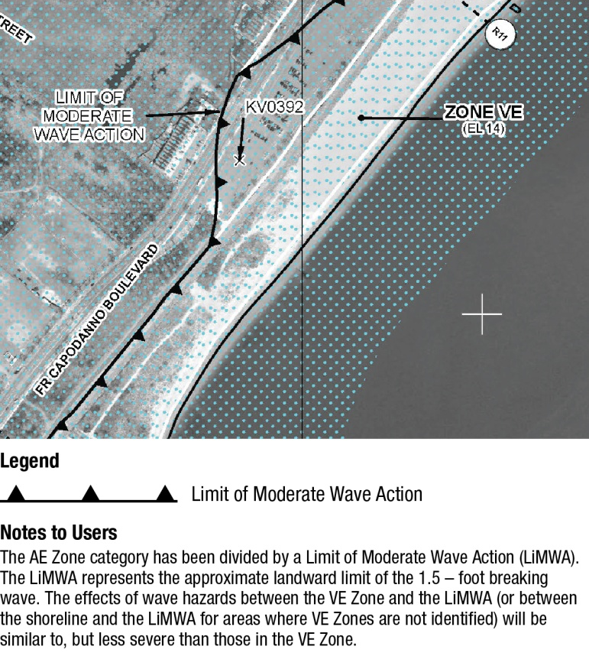***Description**: Post-flood evaluations, engineering calculations and laboratory tests indicate that conventional construction sustains considerable damage when exposed to waves between 3 feet and 1.5 feet high. FEMA draws the inland boundary of the coastal high hazard area (Zone V) where analyses and modeling indicate waves will be less than 3 feet high during the base flood. The NFIP minimum requirements for buildings do not recognize the risk associated with waves less than 3 feet high.

Several years ago FEMA adopted a policy that new studies to revise maps in coastal communities would determine if areas are subject to waves between 3 feet and 1.5 feet. When those conditions are identified, FEMA will delineate the inland extent of the 1.5-foot wave as the Limit of Moderate Wave Action (LiMWA):  Although not labeled on FIRMs, these areas between the LiMWA and the Zone V boundary (or shoreline) are called “Coastal A Zones” (CAZ). FEMA Procedure Memorandum 50 on the decision to identify these areas as an informational layer on Flood Insurance Rate Maps is available onlinehttp://www.fema.gov/media-library/assets/documents/34953.



Keep in mind that even if your current effective Flood Insurance Rate Maps do not show a LiMWA, the maps may be revised in the future as part of FEMA’s nationwide initiative to update FIRMs.

Two alternative ways to adopt Coastal A Zone provisions are shown below:

**Alternative A** requires application of Zone V standards within the CAZ if FEMA has delineated a LiMWA.

**Alternative B** requires application of Zone V standards within an area designated by the community as “Coastal A Zone.” The community selects the area, which may be done by specifying a distance inland from the shore or Zone V boundary, by identifying a specific geographic area, or by delineating specific areas on a map.

**How the FBC, Building addresses CAZ:** The 5th Edition FBC Building, by reference to ASCE 7 (for loads) and to ASCE 24-05, requires the designer to determine if Coastal A Zone conditions exist at a site. If a site is determined to have CAZ conditions, then ASCE 24 requires buildings to be treated the same as buildings in coastal high hazard areas (Zone V), with two exceptions – (1) openings are required in breakaway walls and (2) a Florida-specific amendment allows dry floodproofing provided the structural design accounts for wave loads and erosion and scour.

**ASCE 24 defines the Coastal A Zone** as follows: “Area within a special flood hazard area, landward of a V Zone or landward of an open coast without mapped V Zones. In a Coastal A Zone, the principal source of flooding must be astronomical tides, storm surges, seiches, or tsunamis, not riverine flooding. During the base flood conditions, the potential for breaking wave heights shall be greater than or equal to 1.5 ft.”

How CAZ are handled will change with the 6th Edition FBC and ASCE 24-14, which recognize the CAZ if the FIRM has a LiMWA or if the community designates the CAZ.

**How the FBC, Residential specifies CAZ:** The 5th Edition FBC, R does not require determination of CAZ conditions. However, R322.2 does specify that areas that have been “delineated as subject to wave heights between 1 ½ ft (457 mm) and 3 feet (914 mm) shall be designated as Coastal A Zones.” This means the CAZ applies only if a LiMWA is delineated on the FIRM or if a community otherwise designates an area as subject to such wave conditions. This changes in the 6th Edition FBC: the CAZ is treated like Zone V if the FIRM has a LiMWA or the community designates the CAZ, with the exception of backfilled stemwalls designed for wave loads and to account for scour and erosion.

In terms of allowable foundation types and enclosures, the 5th Edition FBC, R treats CAZs like Zone A (i.e., solid foundations (perimeter walls, stem walls) and elevation on fill are permitted, along with open foundations such as pilings, columns, and piers). In the 5th Edition FBC, R, the only provision specific to CAZ requirement is in R322.2.1, elevation requirements, which specifies that if the CAZ has been designated, then lowest floors shall be elevated to or above the base flood elevation plus 1 foot, or the design flood elevation, whichever is higher. [Note: in communities that use the FIRM, the DFE is the same as the BFE.]

**INSTRUCTIONS.**

***Submit your draft ordinance (in <track changes>) to Technical Support*** [***flood.ordinance@em.myflorida.com***](mailto:flood.ordinance@em.myflorida.com) ***for review well in advance of your first reading.***

**ALTERNATIVE A. Use this set of amendments if FEMA has delineated a LiMWA and the community already has or elects to adopt requirements so that Zone V standards apply in the CAZ.**

Because the FBC, Building, by reference to ASCE 24, already treats CAZ like Zone V, accomplishing this alternative requires changes to local floodplain management regulations and an amendment to the FBC, Residential.

***Step A-1.*** *See the General Instructions to select the appropriate Whereas clause(s). Insert the following brief description of the higher standard:*

|  |
| --- |
| apply coastal high hazard area requirements in areas delineated by FEMA as subject to wave heights between 1 ½ feet and 3 feet, |

***Step A-2.*** *In SECTION 2 of the ordinance package (contains the floodplain management regulations), add a new definition to Section 202 and modify Section 304 as shown so that manufactured homes in Coastal A Zones also have foundations that comply with R322.3 (Zone V).*

|  |
| --- |
| **Coastal A Zone.** Flood hazard areas that have been delineated as subject to wave heights between 1 ½ feet (457 mm) and 3 feet (914 mm). Such areas are seaward of the Limit of Moderate Wave Action shown on the Flood Insurance Rate Map. |
| **304.2 Foundations**. All new manufactured homes and replacement manufactured homes installed in flood hazard areas shall be installed on permanent, reinforced foundations that:  In flood hazard areas (Zone A) other than coastal high hazard areas and Coastal A Zones, are designed in accordance with the foundation requirements of the *Florida Building Code, Residential* Section R322.2 and this ordinance.   1. In coastal high hazard areas (Zone V) and Coastal A Zones, are designed in accordance with the foundation requirements of the *Florida Building Code, Residential* Section R322.3 and this ordinance. |

***Step A-3.*** *In SECTION 2 of the ordinance package (contains the floodplain management regulations), modify sections 307.5, 307.6, 307.7, and 307.8 as follows:*

* **In all of the titles of those sections,** change to “coastal high hazard areas (Zone V) and Coastal A Zones”
* **In all of the introductory sentences of those sections,** change to “coastal high hazard areas and Coastal A Zones”

***Step A-4.*** *Add a new SECTION 3 to the ordinance package to adopt local technical amendments to the FBC, Residential as follows. Note: the text changes shown below will appear in the 6th Edition FBC, Residential. If you adopt this now, you will not need to modify your local technical amendments when the 6th Edition is effective. Also note the 6th Ed. FBC, Residential requires minimum elevations of BFE + 1 foot. See instructions for Additional Elevation to see what that looks like.*

*Maintain strikethrough and underlining to denote changes to the FBC.*

|  |
| --- |
| **SECTION 3. The *Florida Building Code, Residential* is hereby amended by the following technical amendments*.***  **R322.2 Flood hazard areas (including A Zones).** Areas that have been determined to be prone to flooding and that are not subject to high-velocity wave action shall be designated as flood hazard areas. Flood hazard areas that have been delineated as subject to wave heights between 1 ½ feet (457 mm) and 3 feet (914 mm) or otherwise designated by the jurisdiction shall be designated as Coastal A Zones and are subject to the requirements of Section R322.3. Buildings and structures constructed in whole or in part in flood hazard areas shall be designed and constructed in accordance with Sections R322.2.1 through R322.2.3. |
| **R322.2.1 Elevation requirements.**  1. Buildings and structures in flood hazard areas not designated as Coastal A Zones shall have the lowest floors elevated to or above the design flood elevation.  ~~2. Buildings and structures in flood hazard areas designated as Coastal A Zones shall have the lowest floors elevated to or above the base flood elevation plus 1 foot (305 mm), or to the design flood elevation, whichever is higher.~~  2. ~~3.~~ In areas of shallow flooding (AO Zones), buildings and structures shall have the lowest floor (including basement) elevated at least as high above the highest adjacent grade as the depth number specified in feet on the FIRM, or at least 2 feet (610 mm) if a depth number is not specified.  3. ~~4.~~ Basement floors that are below grade on all sides shall be elevated to or above the design flood elevation.  **Exception:** Enclosed areas below the design flood elevation, including basements whose floors are not below grade on all sides, shall meet the requirements of Section R322.2.3. |
| **R322.3 Coastal high-hazard areas (including V Zones and Coastal A Zones, where designated).** Areas that have been determined to be subject to wave heights in excess of 3 feet (914 mm) or subject to high-velocity wave action or wave-induced erosion shall be designated as coastal high-hazard areas. Flood hazard areas that have been designated as subject to wave heights between 1 ½ (457 mm) and 3 feet (914 mm) or otherwise designated by the jurisdiction shall be designated as Coastal A Zones. Buildings and structures constructed in whole or in part in coastal high-hazard areas and Coastal A Zones, where designated, shall be designed and constructed in accordance with Sections R322.3.1 through R322.3.6. |
| ***NOTE: the exception to R322.3.3 shown below will be in the 6th Edition FBC (expected mid-2017), but you should not adopt it now if your intent is to require open foundations in Coastal A Zone (which yields the most CRS points).***  **R322.3.3 Foundations.** Buildings and structures erected in coastal high-hazard areas and Coastal A Zones shall be supported on pilings or columns and shall be adequately anchored to such pilings or columns. The space below the elevated building shall be either free of obstruction or, if enclosed with walls, the walls shall meet the requirements of Section R322.3.4. Pilings shall have adequate soil penetrations to resist the combined wave and wind loads (lateral and uplift). Water-loading values used shall be those associated with the design flood. Wind-loading values shall be those required by this code. Pile embedment shall include consideration of decreased resistance capacity caused by scour of soil strata surrounding the piling. Pile systems design and installation shall be certified in accordance with Section R322.3.6. Spread footing, mat, raft or other foundations that support columns shall not be permitted where soil investigations that are required in accordance with Section R401.4 indicate that soil material under the spread footing, mat, raft or other foundation is subject to scour or erosion from wave-velocity flow conditions. If permitted, spread footing, mat, raft or other foundations that support columns shall be designed in accordance with ASCE 24. Slabs, pools, pool decks and walkways shall be located and constructed to be structurally independent of buildings and structures and their foundations to prevent transfer of flood loads to the buildings and structures during conditions of flooding, scour or erosion from wave-velocity flow conditions, unless the buildings and structures and their foundation foundations are designed to resist the additional flood load.  **Exception:** In Coastal A Zones, stem wall foundations supporting a floor system above and backfilled with soil or gravel to the underside of the floor system shall be permitted provided the foundations are designed to account for wave action, debris impact, erosion and local scour. Where soils are susceptible to erosion and local scour, stem wall foundations shall have deep footings to account for the loss of soil. |
| **R322.3.4 Walls below design flood elevation.** Walls and partitions are permitted below the elevated floor, provided that such walls and partitions are not part of the structural support of the building or structure and:   1. Electrical, mechanical, and plumbing system components are not to be mounted on or penetrate through walls that are designed to break away under flood loads; and 2. Are constructed with insect screening or open lattice; or 3. Are designed to break away or collapse without causing collapse, displacement or other structural damage to the elevated portion of the building or supporting foundation system. Such walls, framing and connections shall have a design safe loading resistance of not less than 10 (470 Pa) and no more than 20 pounds per square foot (958 Pa); or 4. Where wind loading values of this code exceed 20 pounds per square foot (958 Pa), the construction documents shall include documentation prepared and sealed by a registered design professional that:   4.1. The walls and partitions below the design flood elevation have been designed to collapse from a water load less than that which would occur during the design flood.  4.2. The elevated portion of the building and supporting foundation system have been designed to withstand the effects of wind and flood loads acting simultaneously on all building components (structural and nonstructural). Water loading values used shall be those associated with the design flood. Wind loading values used shall be those required by this code.   1. In Coastal A Zones, walls shall be provided with flood openings that meet the criteria in R322.2.2, Item 2. |

**ALTERNATIVE B. Use this set of changes if FEMA has not delineated a LiMWA and the community already has or elects to adopt requirements so that Zone V standards apply within CAZ specified by a geographic designation or local map.**

Because the FBC, Building, by reference to ASCE 24, already treats CAZ like Zone V, accomplishing this alternative only requires amendment of the floodplain management regulations and the FBC, Residential.

**Instructions:** Where this **{see Note}** appears in the text below, insert the CAZ description your community uses. The following are examples only:

* Within five hundred (500) feet inland of the Zone V boundary
* Within two hundred (200) feet of the mean high tide line
* Within areas identified on *{cite community’s own adopted map and date of adoption}*
* Seaward of *{select appropriate boundary, such as a road}*

***Step B-1.*** *See the General Instructions to select the appropriate Whereas clause(s). Insert the following brief description of the higher standard:*

|  |
| --- |
| apply coastal high hazard area requirements in certain designated areas that are subject to moderate wave action, |

***Step B-2.***  *In SECTION 2 of the ordinance package (contains the floodplain management regulations), add a new definition to Section 202 and modify Section 304 as shown so that manufactured homes in Coastal A Zones also have foundations that comply with R322.3 (Zone V).*

|  |
| --- |
| **Coastal A Zone.** Flood hazard areas that are **{see Note}.** |
| **304.2 Foundations**. All new manufactured homes and replacement manufactured homes installed in flood hazard areas shall be installed on permanent, reinforced foundations that:  In flood hazards areas (Zone A) other than coastal high hazard areas and Coastal A Zones, are designed in accordance the foundation requirements of the *Florida Building Code, Residential* Section R322.2 and this ordinance.   1. In coastal high hazard areas (Zone V) and Coastal A Zones, are designed in accordance with the foundation requirements of the *Florida Building Code, Residential* Section R322.3 and this ordinance. |

***Step B-3.*** *In SECTION 2 of the ordinance package (contains the floodplain management regulations), modify sections 307.5, 307.6, 307.7, and 307.8 as follows:*

* **In all of the titles of those sections,** change to “coastal high hazard areas (Zone V) and Coastal A Zones”
* **In all of the introductory sentences of those sections,** change to “coastal high hazard areas and Coastal A Zones”

***Step B-4.*** *Add a new SECTION 3 to the ordinance package to adopt local technical amendments to the FBC, Residential – USE EXACTLY THE SAME AMENDMENTS AS SHOWN IN STEP A-4.*